HOMEWORK ASSIGNMENT 5

1. Exercise 19.3.1 (Page 522)

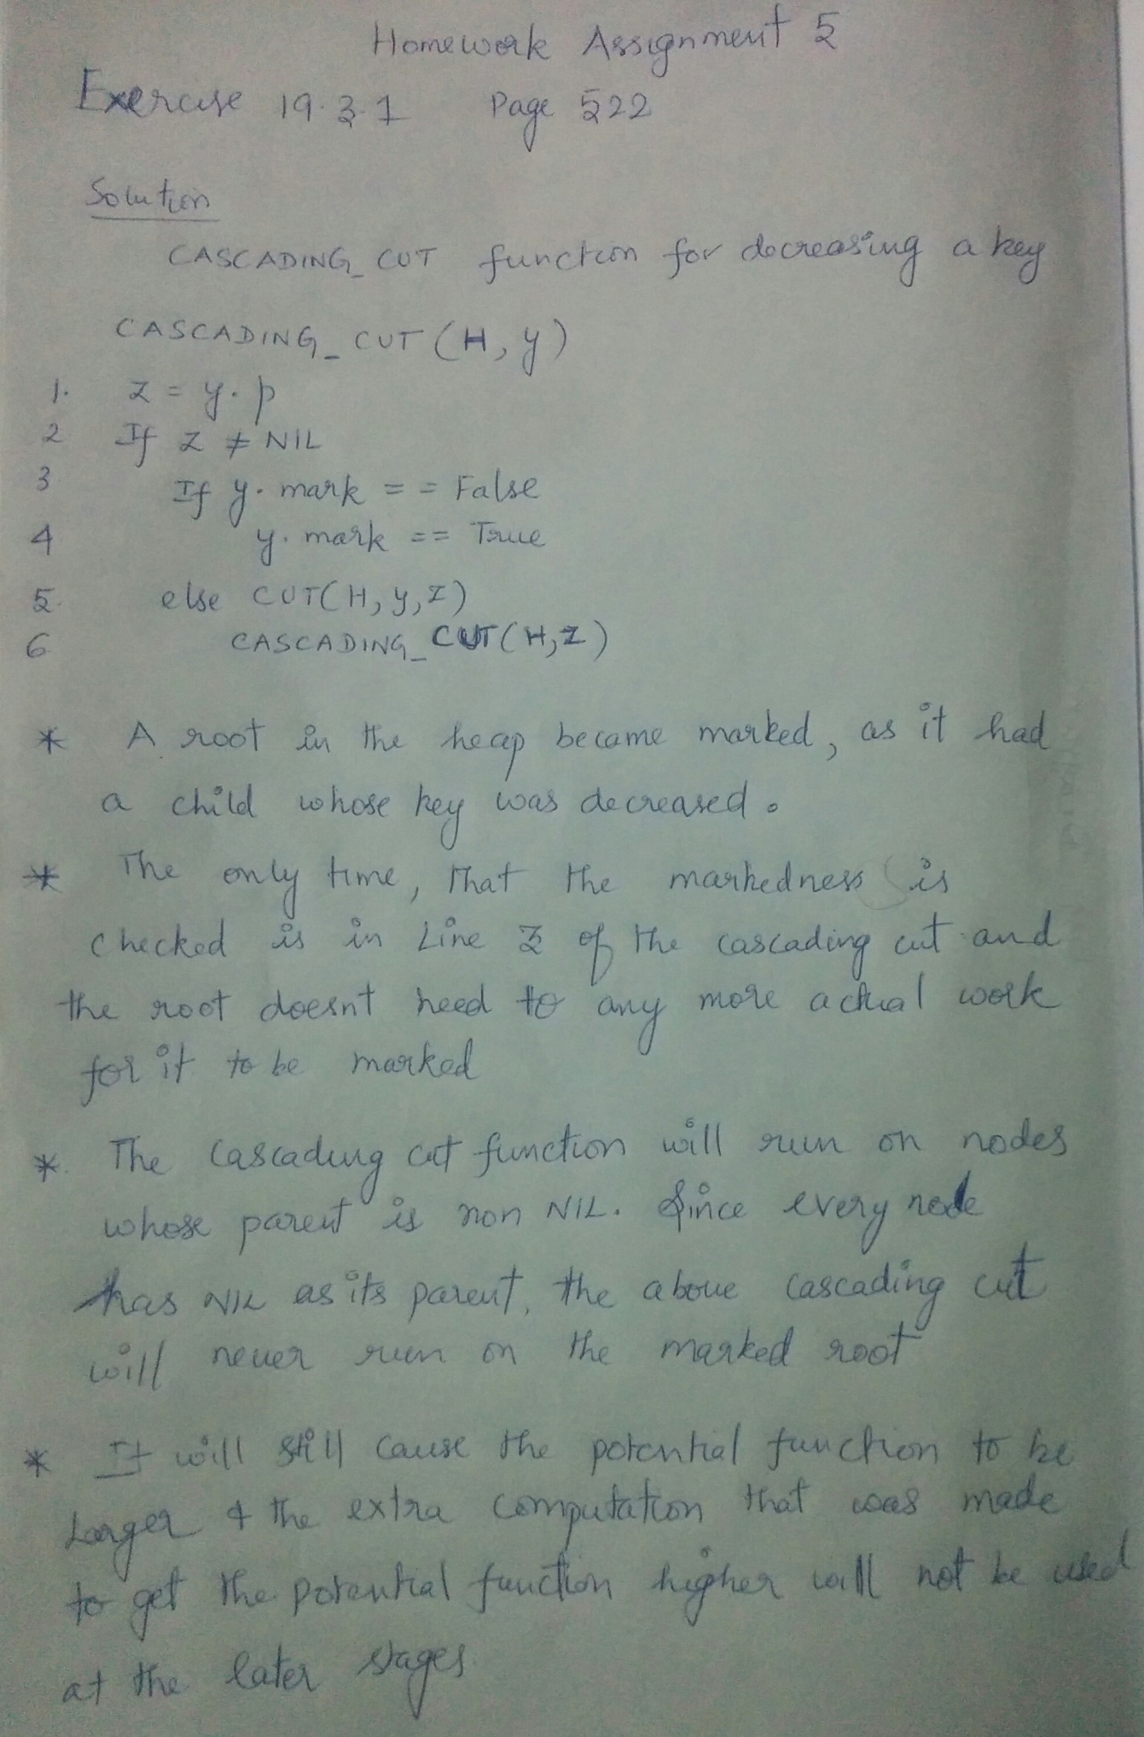

2. Problem 19-3 (Page 529)

